Vocabulary

|  |  |  |  |  |
| --- | --- | --- | --- | --- |
| * river | * Water cycle | * Source | * River course | * Land use |

**What is a river’s journey?**

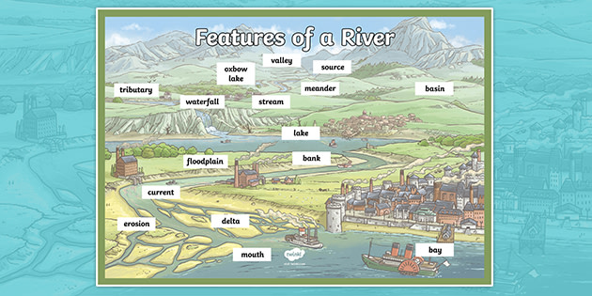

Living next to a river

**Advantages:** view and landscape, water for farming, recreation, jobs (near estuaries), money through tourism.

**Disadvantages:** flooding, erosion, water pollution, noise and tourists.

**Amazon -** South America

**Nile -** Africa

**Yangtze -** Asia

**Volga -** Europe

**Mississippi -** North America

**Avon-** Warwickshire

Courses of a river

* **Upper course:** steep-sided V-shaped valleys, interlocking spurs, rapids, waterfalls and gorges.
* **Middle course:** wider, shallower valleys, meanders, and oxbow lakes.
* **Lower course:** wide flat-bottomed valleys, floodplains and deltas.