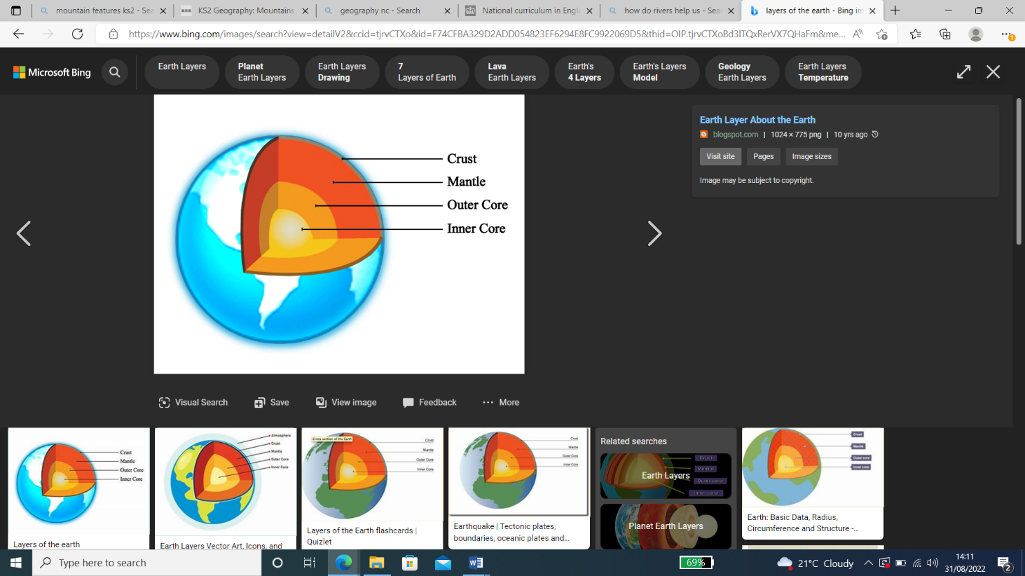

Earthquakes

* Happen because of tectonic plates.
* Happen on fault lines (where two plates meet).
* Have an epicentre.
* Can cause aftershocks.

Naples

Naples has a coastline on the Tyrrhenian Sea. It is a major tourist destination in Italy. It has restaurants, castles, churches and a port. The city of Pompeii borders Naples. An ancient volcano called Vesuvius erupted and destroyed the city.

Vocabulary

|  |  |  |  |  |
| --- | --- | --- | --- | --- |
| * Volcano | * Earthquake | * Pompeii | * Vegetation belt | * Tectonic plate |

**How do different natural disasters impact on locations and people?**

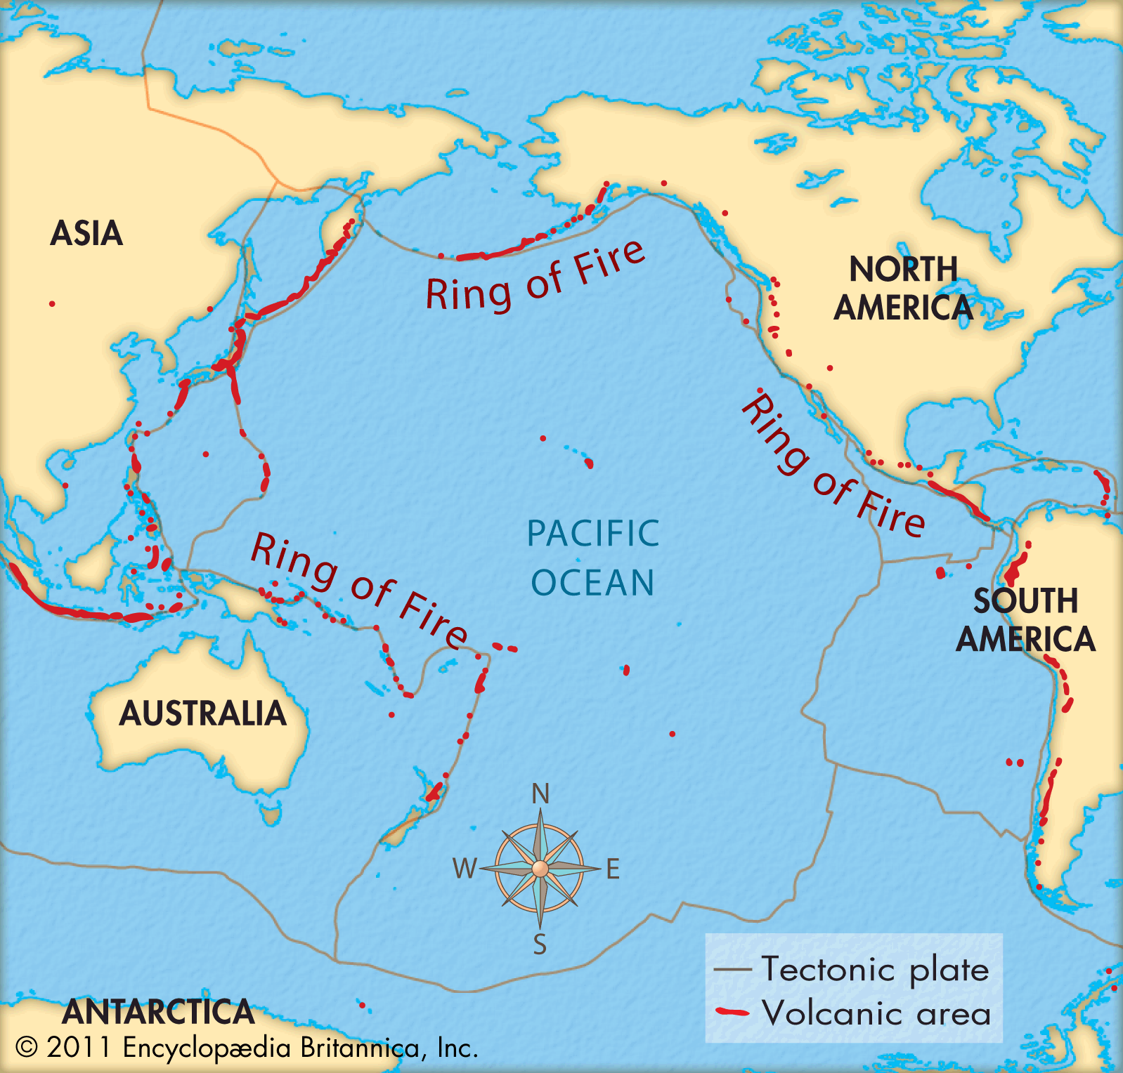

Naples

Naples has a coastline on the Tyrrhenian Sea. It is a major tourist destination in Italy. It has restaurants, castles, churches and a port. The city of Pompeii borders Naples. An ancient volcano called Vesuvius erupted and destroyed the city.

Living near a volcano