/p

Vocabulary

|  |  |  |  |  |
| --- | --- | --- | --- | --- |
| * legacy | * Athens | * Sparta | * Democracy | * Alexander the Great |

**What legacy did the Greeks leave on the western world?**

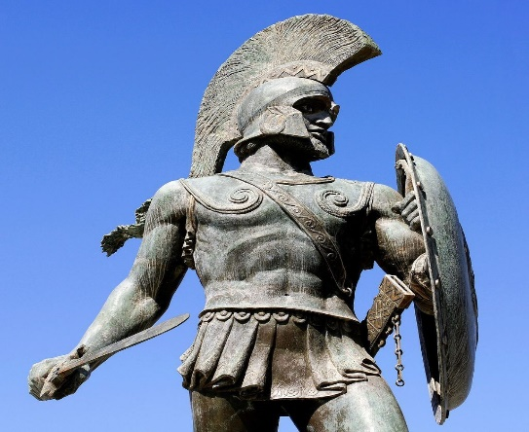

Greece

Greece is located on the Mediterranean and Aegean sea. It was made up of many city states that had their own democracy to rule them.

Athens

Athens was a city state of Greece. It has a sea-based army because it was near the coast. It was ruled by a democracy meaning people could vote for what they wanted. In Athens, education was a priority but only for boys. Women in Athens didn’t have as many rights as Spartan women, they couldn’t go to school, own property or join the army. Athens did trade with other cities though and they were a lot more open.

Spartan warrior statue

Legacy

There are many things that we do today that the Greeks began such as the Olympics, architecture, democracy and medicine. A legacy is something that people remember you for.

Alexander the Great

Was one of the most powerful army leaders the world has ever seen. He invaded Egypt and founded the city of Alexandria. He also tried to conquer all of India too.